Statistics

1. Data types in statistics
2. Categorical and Numerical
3. Levels of data

* Nominal level
* Ordinal level
* Interval level
* Ratio level

1. Population
2. Sample
3. Population vs Sample
4. Inferential statistics
5. Frequency table: class vs frequency
6. Relative frequency table
7. Bar chart
8. Pie chart
9. Frequency distributed table: CI vs Interval freq
10. Histogram
11. Distribution graph
12. Central tendency
13. Mean- Median-mode
14. Mean vs Median
15. Outliers
16. Skewed data
17. Pos – Neg – normal
18. Bi mode – Uni mode – Multi mode
19. Data dispersion
20. Range : It will not consider middle value
21. Mean deviation: ; Total deviation =0
22. AMD: : graph is dis cont at point zero
23. Variance : value will be raise as well as units also
24. Standard deviation
25. Variance : how a data is varying it self
26. Covariance: how a data is varying w.r.t other variable
27. Pos or neg or neutral
28. Covariance Matrix
29. Pearson Correlation ( r ) -1 to 1 : cov(x,y)/std(x) * std(y)
30. Percentile
31. Quartile
32. Outliers analysis
33. Box plot

Plots:

1. Bar plot : Class vs Frequency
2. Pie chart: Relative frequency
3. Histogram : CI vs Frequency
4. Distribution plot : Data flow
5. Box plot : To find the outliers
6. Scatter plot : two variables plot

Relation between two variables

How to Deal the Outliers

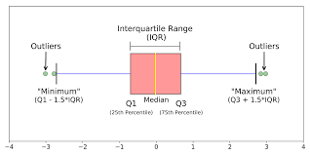

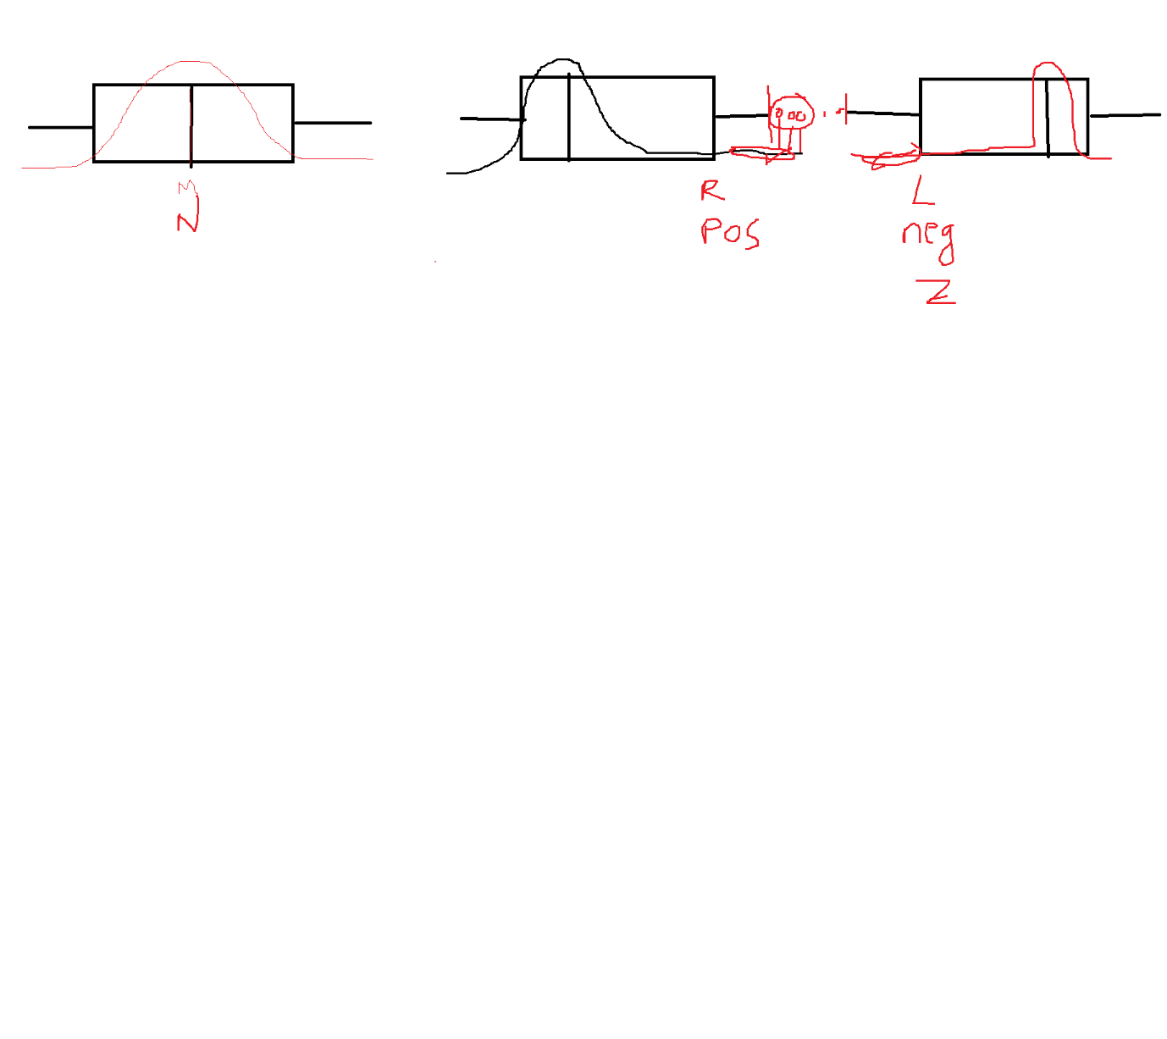

$$q_{1}-1.5*IQR or q_{3}+1.5*IQR Mild$$

$$q_{1}-3*IQR or q_{3}+3*IQR Huge$$

$$IQR=q_{3}-q_{1}$$

$$Outliers looks like a black spots in the box plot$$

$$Outliers are affets the data, your conclusion goes wrong$$

$$1) Drop the outliers or observations which are outliers$$

$information will loss$

$If you want to develop any ML model we required data should be more$

$<5\% or <2\% then drop the observations$

$$2)Will find the outliers, will replace all the outliers with Median value$$

$$3) We can cap the values those outlier which are less than Q1 cap with Q1 value$$

$$those observations are greater than Q3 cap with Q3 value$$

$$Normal distribution:$$

$$Bell shaped curve : 50\% data left side and 50\% data right side$$

$$Mean=Median=Mode$$

$$All the examinations CAT GMAT GATE try to follow Normal distributions$$

$$All the maths developed in statistics by assumption , the data follows normal distribution$$

$$For Normal distribution we have a formulae:$$

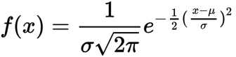

$Emperical Rule: 68-95-99.7$

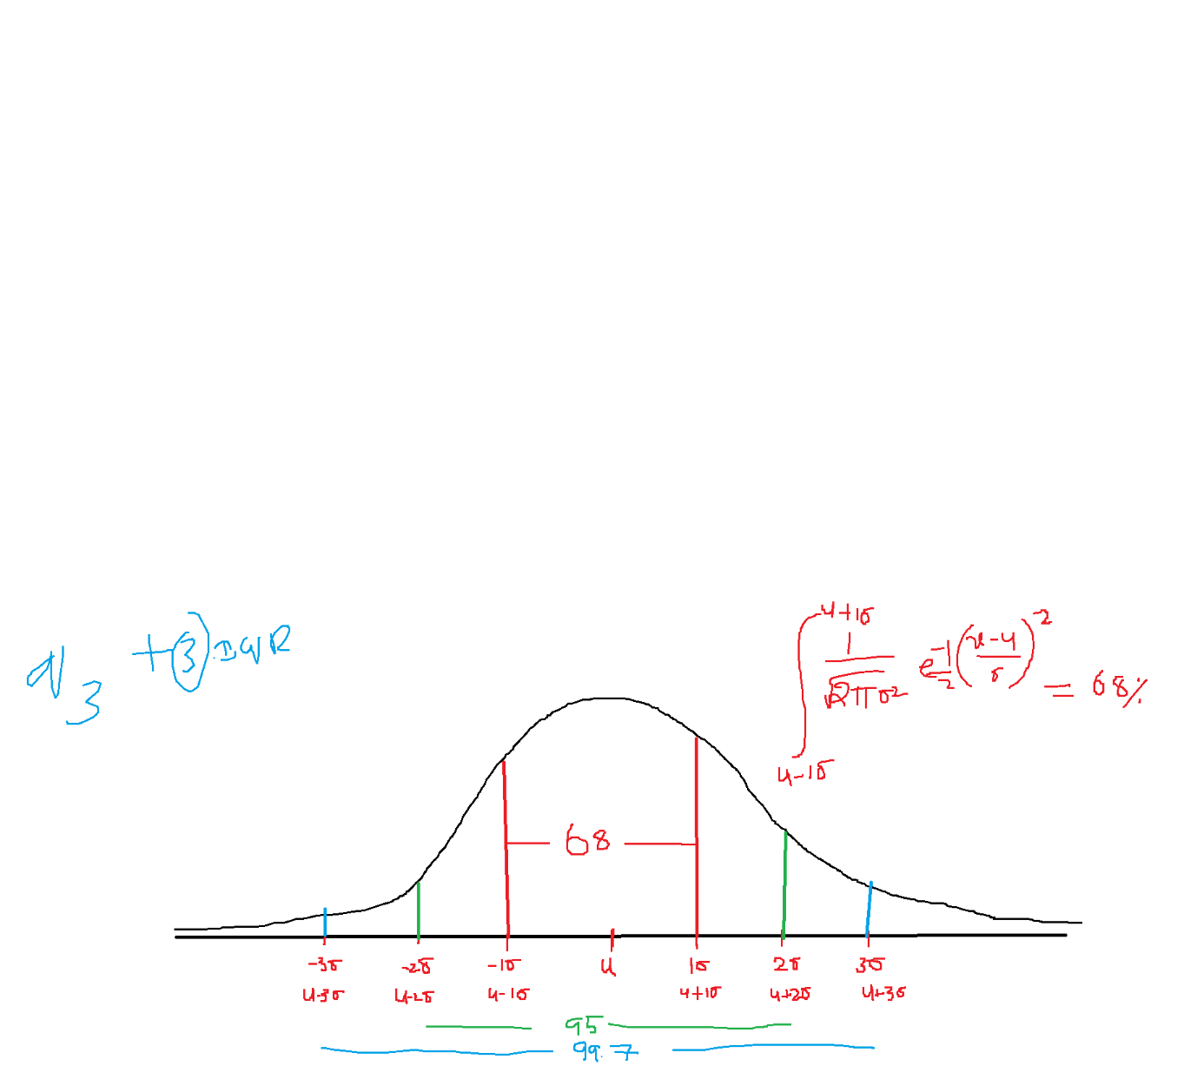

$u-1σ to u+1σ=68\% of data will cover$

$$u-2σ to u+2σ=95 \% of data will cover$$

$$u-3σ to u+3σ=99.7\% of data will cover$$

$$In Normal distribution almost total data between -3σ to+3σ only$$

$$That^{'}s why in outlier we multiplied by 3 with IQR$$

$$we get these value by conduction area under the curve concept$$

$$we know Normal distribution Formulae, will integrate that formule within limits$$

$$∫\dot{f}(x)$$

Use case:

Assume that In India The average petrol rate is 100rs, by ever state on of average it will vary by 2 rs

$$u=100;σ=2$$

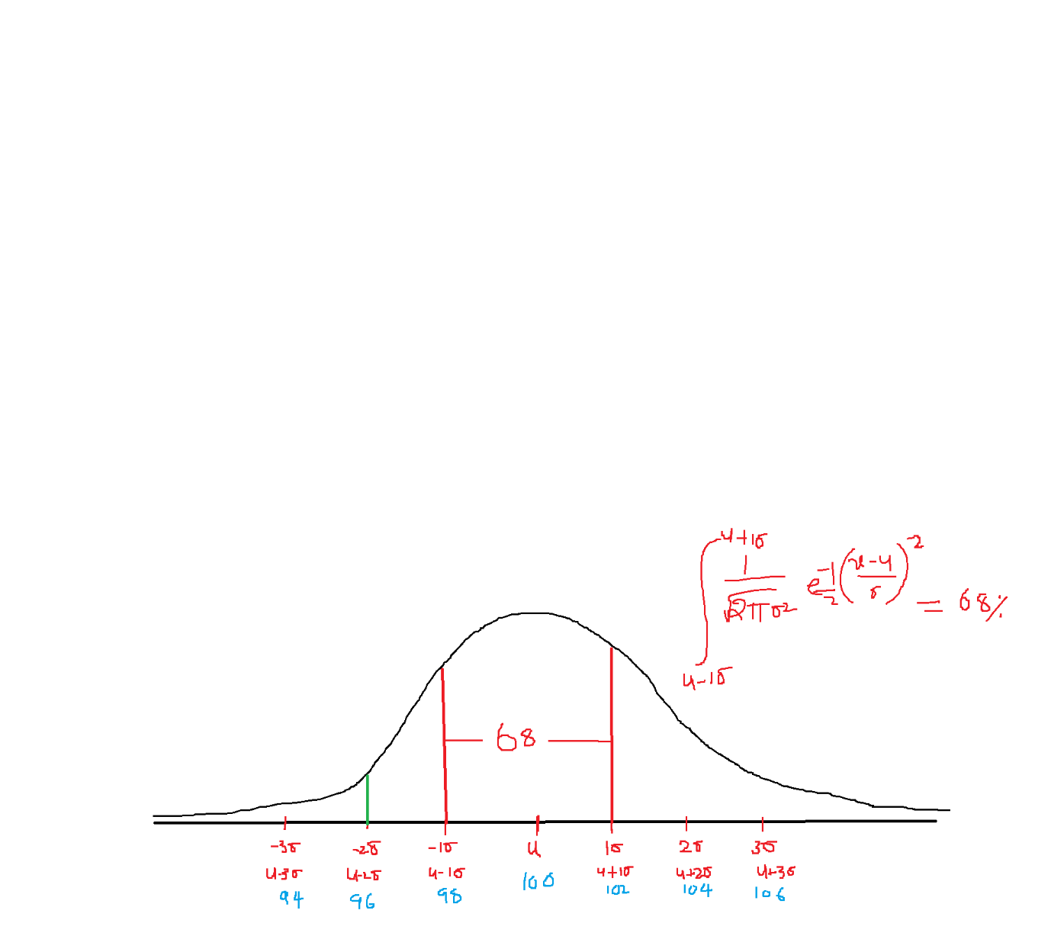

$$u-1σ to u+1σ=100-1*2 to 100+1*2=98 to 102$$

$$out of total states In India 68\% of states having petrol rates between 98 to 102$$

$$u-2σ to u+2σ=100-2*2 to 100+2*2=96 to 104$$

$$out of total states In India 95\% of states having petrol rates between 96 to 104$$

$$u-3σ to u+3σ=100-3*2 to 100+3*2=94 to 106$$

$$out of total states In India 99.7\% of states having petrol rates between 94 to 106$$

$$In india the minimum petrol rate is 94rs and the maximum petrol rate is 106rs$$

$$If data does not follows Normal distribution:$$

$Convert into Normal distribution:Data transformation Tech.$

$chebyshive inequality or Chebyshive Theorem$

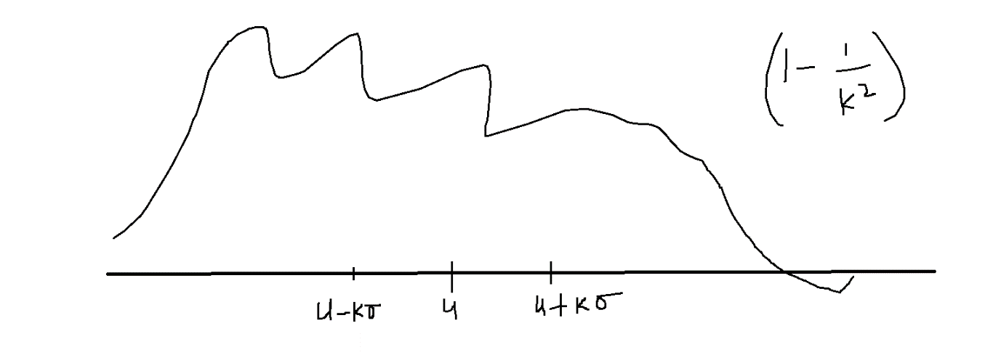

$$how much data coverage$$

$$u-kσ to u+kσ=1-\frac{1}{k^{2}}$$

$$assume that=k=2$$

$$the data not follows normal distribution$$

$$for 2 std$$

$$u-2σ to u+2σ=1-\frac{1}{2^{2}}=\frac{3}{4}=75\%$$

$$chebyshive inequality fail when you take data 1σ=1-\frac{1}{1^{2}}=0$$

$$u-kσ to u+kσ=1-\frac{1}{k^{2}}$$

$$u-1σ to u+1σ=1-\frac{1}{1^{2}}=0$$

$$u-2σ to u+2σ=1-\frac{1}{2^{2}}=75$$

$$u-3σ to u+3σ=1-\frac{1}{3^{2}}≅90$$

|  |  |
| --- | --- |
| $$Normal Distribution 68-95-99.7$$ | $$Chebyshive: 1-\frac{1}{k^{2}}$$ |
| $$u-1σ to u+1σ=68$$ | $$u-1σ to u+1σ=0$$ |
| $$u-2σ to u+2σ=95$$ | $$u-2σ to u+2σ=75$$ |
| $$u-3σ to u+3σ=99.7$$ | $$u-3σ to u+3σ=90$$ |